Lab Assignment AWS 2 (5 Amazon AWS)

Chaudhary Hamdan

1905387

Date: 17-02-2022

Question: Amazon AWS Module 5 completion

Screenshots:

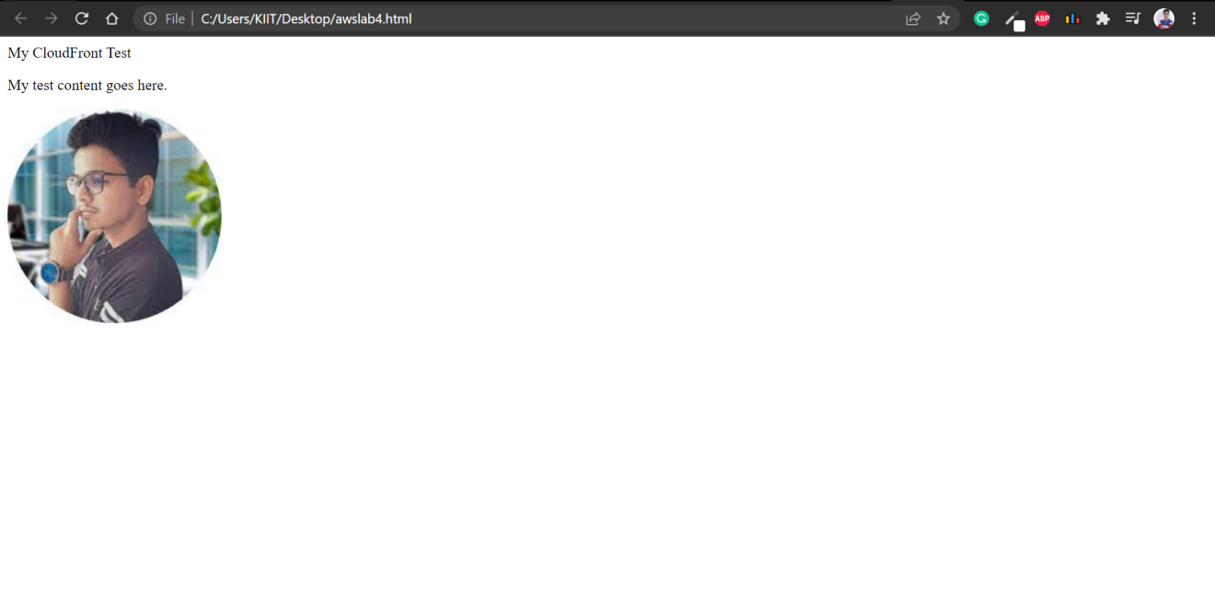

Code:

<html>

<head>My CloudFront Test</head>

<body>

<p>My test content goes here.</p>

<p><img src="http://d3abgbm492nncb.cloudfront.net/image.jpg" alt="my test image">

</body>

</html>